LAPORAN PRAKTIKUM MATA KULIAH

PEMROGRAMAN BERBASIS FRAMEWORK



Nama : Alenovan Wiradhika Putra

Kelas : TI-3C D-IV T.INFORMATIKA

NIM : 1741720065

No. Absen : 02

PROGRAM STUDI D-IV TEKNIK INFORMATIKA

JURUSAN TEKNOLOGI INFORMASI

POLITEKNIK NEGERI MALANG

2020

**Praktikum**

1. **Menginstall redux**

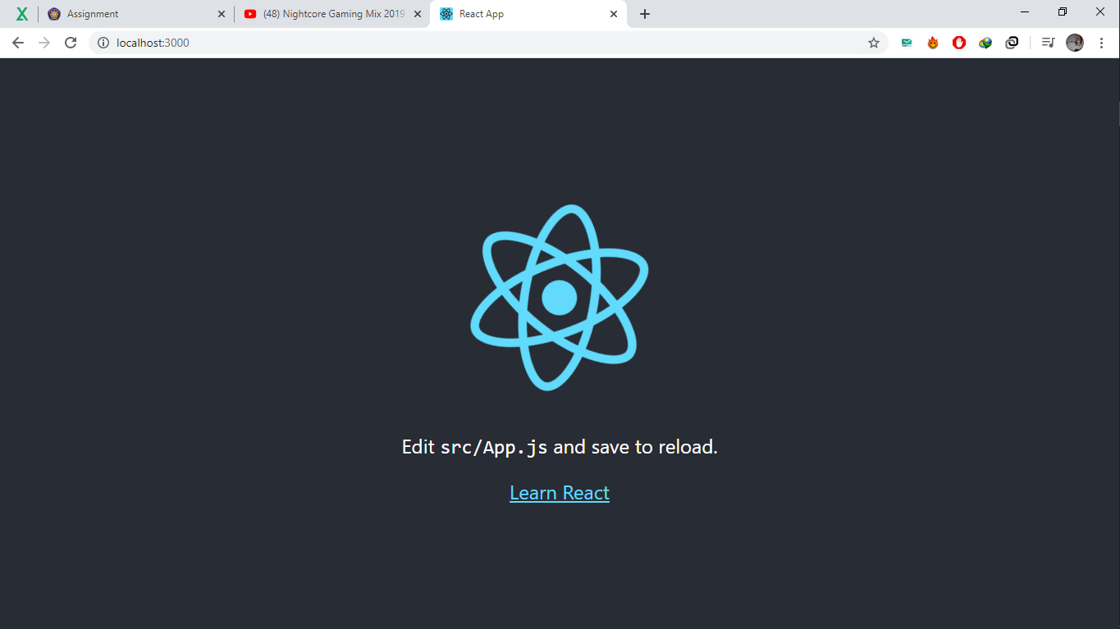

1. **Menginstall form**

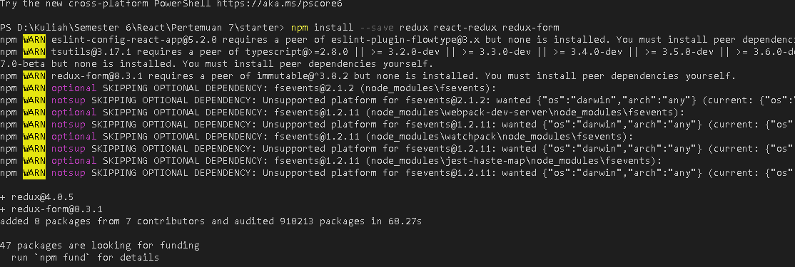

1. **Source code file index.html**
2. <!DOCTYPE html>
3. <html lang="en">
4. <head>
5. <meta charset="utf-8" />
6. <meta name="viewport" content="width=device-width, initial-scale=1, shrink-to-fit=no" />
7. <meta name="theme-color" content="#000000" />
8. <link rel="manifest" href="%PUBLIC_URL%/manifest.json" />
9. <link rel="shortcut icon" href="%PUBLIC_URL%/favicon.ico" />
10. <link rel="stylesheet" href="https://cdnjs.cloudflare.com/ajax/libs/bulma/0.6.2/css/bulma.min.css" />
11. <title>React App</title>
12. </head>
13. <body>
14. <noscript>You need to enable JavaScript to run this app.</noscript>
15. <div id="root"></div>
16. </body>
17. </html>
18. **Source code pada file index.js**

import React from 'react';

import ReactDOM from 'react-dom';

import { createStore, combineReducers } from 'redux';

import { Provider } from 'react-redux';

import { reducer as formReducer } from 'redux-form';

import './index.css';

import App from './App';

import * as serviceWorker from './serviceWorker';

const rootReducer = combineReducers({

  form: formReducer,

});

const store = createStore(rootReducer);

ReactDOM.render(

  <Provider store={store}>

    <App />

  </Provider>,

  document.getElementById('root')

);

// If you want your app to work offline and load faster, you can change

// unregister() to register() below. Note this comes with some pitfalls.

// Learn more about service workers: https://bit.ly/CRA-PWA

serviceWorker.unregister();

1. **Source code pada file App.js**
2. import React, { Component } from 'react';
3. import { reduxForm, Field } from 'redux-form';
4. import logo from './logo.svg';
5. import './App.css';
6. let SignInForm = props => {
7. const { handleSubmit } = props;
8. return <form onSubmit={handleSubmit} className="form">
9. <div className="field">
10. <div className="control">
11. <Field name="firstName" component={renderField} type="text" label="First Name" />
12. </div>
13. </div>
14. <div className="field">
15. <div className="control">
16. <Field name="lastName" component={renderField} type="text" label="Last Name" />
17. </div>
18. </div>
19. <div className="field">
20. <div className="control">
21. <Field name="email" component={renderField} type="email" label="Email Address" />
22. </div>
23. </div>
24. <div className="field">
25. <div className="control">
26. <Field name="age" component={renderField} type="number" label="Age" />
27. </div>
28. </div>
29. <div className="field">
30. <div className="control">
31. <label className="label">Proficiency</label>
32. <div className="select">
33. <Field className="input" name="proficiency" component="select">
34. <option />
35. <option value="beginner">Beginner Dev</option>
36. <option value="intermediate">Intermediate Dev</option>
37. <option value="expert">Expert Dev</option>
38. </Field>
39. </div>
40. </div>
41. </div>
42. <div className="field">
43. <div className="control">
44. <label className="label">Gender</label>
45. <label className="radio">
46. <Field name="gender" component="input" type="radio" value="male" />
47. {''}
48. Male
49. </label>
50. <label className="radio">
51. <Field name="gender" component="input" type="radio" value="female" />
52. {''}
53. Female
54. </label>
55. </div>
56. </div>
57. <div className="field">
58. <div className="control">
59. <label className="checkbox">
60. <Field name="saveDetails" id="saveDetails" component="input" type="checkbox" />
61. Save Details
62. </label>
63. </div>
64. </div>
65. <div className="field">
66. <div className="control">
67. <label className="label">Message</label>
68. <Field className="textarea" name="message" component="textarea" />
69. </div>
70. </div>
71. <div className="field">
72. <div className="control">
73. <button className="button is-link">Button</button>
74. </div>
75. </div>
76. </form>
77. };
78. const validate = val => {
79. const errors = {};
80. if (!val.firstName) {
81. console.log('First name is required');
82. errors.firstName = 'Required';
83. }
84. if (!val.lastName) {
85. console.log('Last name is required');
86. errors.lastName = 'Required';
87. }
88. if (!val.email) {
89. console.log('Email is required');
90. errors.email = 'Required';
91. } else if (!/^.+@.+$/i.test(val.email)) {
92. console.log('email is invalid');
93. errors.email = 'Invalid email address';
94. }
95. if (!val.age) {
96. errors.age = 'Required';
97. } else if (isNaN(Number(val.age))) {
98. errors.age = 'Must be a number';
99. } else if (Number(val.age) < 18) {
100. errors.age = 'Sorry, you must be at least 18 years old';
101. }
102. return errors;
103. };
104. const renderField = ({ input, label, type, meta: { touched, error, warning } }) => (
105. <div>
106. <div className="control">
107. <label className="field">{label}</label>
108. <input className="input"{...input} placeholder={label} type={type} />
109. {touched && ((error && <span>{error}</span>) || (warning && <span>{warning}</span>))}
110. </div>
111. </div>
112. )
113. SignInForm = reduxForm({
114. form: 'signIn',
115. validate,
116. })(SignInForm);
117. class App extends Component {
118. handleSignIn = values => {
119. console.log(values);
120. };
121. render() {
122. return (
123. <div className="App">
124. <header className="App-header">
125. <img src={logo} className="App-logo" alt="logo" />
126. <h1 className="App-title">Welcome to React x Redux-Form</h1>
127. </header>
128. <div className="container">
129. <p className="App-intro">Contact Form</p>
130. <SignInForm onSubmit={this.handleSignIn} />
131. </div>
132. </div>
133. );
134. }
135. }
136. // function App() {
137. //   return (
138. //     <div className="App">
139. //       <header className="App-header">
140. //         <img src={logo} className="App-logo" alt="logo" />
141. //         <p>
142. //           Edit <code>src/App.js</code> and save to reload.
143. //         </p>
144. //         <a
145. //           className="App-link"
146. //           href="https://reactjs.org"
147. //           target="_blank"
148. //           rel="noopener noreferrer"
149. //         >
150. //           Learn React
151. //         </a>
152. //       </header>
153. //     </div>
154. //   );
155. // }
156. export default App;
157. **Hasil :**

